1. INTRODUCTION
  - Overview
Existing System:

Virtual assistants are typically cloud-based programs that require internet-connected devices and/or applications to work. Three such applications are Siri on Apple devices, Cortana on Microsoft Devices and Google Assistant on Android devices. There are also devices dedicated to providing virtual assistance. The most popular ones are available from Amazon, Google and Microsoft. it is ready to receive a command, which typically involves simple language requests, such as "what is the weather today," or "play pop music." Those requests are processed and stored amounts of data, which feeds artificial intelligence platforms, natural language in google cloud. The technologies that power virtual assistants require massive processing. As the end user interacts with a virtual assistant, the AI programming uses sophisticated algorithms to learn from data input and become better at predicting the end user needs.
Proposed System:
To design a device that acts as a digital organizer to provide variety of services to its master. It will look at examples of intelligent programs with natural language processing that are currently available, with different categories of support, and examine the potential usefulness of one specific piece of software as a VA. It continues to expand its digital abilities in organizing events, ordering food, playing music, guiding , game prediction etc. The concept of a virtual assistant which is a digital service looking after a range of our needs is fast becoming a reality. digital assistants are set to become our gateway to the internet and know more about us than we do ourselves. Siri and Google now are just the beginning. The device accepts voice input processes to provide desired output to user.

1.2 Project Objective & Scope

Objective:
Main objective of building virtual assistant software is using semantic data sources available on the web, user generated content and providing knowledge from knowledge databases. The main purpose of an intelligent virtual assistant is to answer questions that users may have. This may be done in a business environment, for example, on the business website, with a chat interface. On the mobile platform, the intelligent virtual assistant is available as a call-button operated service where a voice asks the user “What can I do for you?” and then responds to verbal input. Virtual assistants can tremendously save you time. We spend hours in online research and then making the report in our terms of understanding. V.A can do that for you. Provide a topic for research and continue with your tasks while VA does the research. Another difficult task is to remember test dates, birth dates or anniversaries. It comes with a surprise when you enter the class and realize it is class test today. Just tell VA in advance about your tests and she reminds you well in advance so you can prepare for the test. One of the main advantages of voice searches is their rapidity. In fact, voice is reputed to be four times faster than a written search: whereas we can write about 40 words per minute, we are capable of speaking around 150 during the same period of time 15. In this respect, the ability of personal assistants to accurately recognize spoken words is a prerequisite for them to be adopted by consumers.
Scope:
voice assistants will continue to offer more individualized experiences as they get better at differentiating between voices. However, it’s not just developers that need to address the complexity of developing for voice as brands also need to understand the capabilities of each device and integration and if it makes sense for their specific brand. They will also need to focus on maintaining a user experience that is consistent within the coming years as complexity becomes more of a concern. This is because the visual interface with voice assistants is missing. Users simply cannot see or touch a voice interface.

1.3 Organization of Report
This report contains 10 chapters with supporting appendixes. Chapter 2 is Background and Literature Survey. It includes software requirement specification, feasibility study and proposed project model. It tells about the usefulness and market potential of virtual system. Chapter 3 is Process Model which describes the incremental model. Chapter 4 includes all the diagrams like data flow diagram, activity diagram etc.Chapter 5 describes the technical details like software and hardware specifications. Chapter 6 and 7 include Coding and Testing phases. Chapter 8 displays the screen layouts. Chapter 9 and 10 are Future Enhancements and Conclusion followed by Bibliography and appendixes.

2. BACKGROUND AND LITERATURE SURVEY
2.1 Software Requirement Specification
virtual assistant software is required to act as an interface into the digital world by understanding user requests or commands and then translating into actions or recommendations based on agent’s understanding of the world. VA focuses on relieving the user of entering text input and using voice as primary means of user input. Agent then applies voice recognition to records the input. It then use this input to call one of the personal information management applications such as task list or calendar to record a new entry or to search about it on search engines like Google, Bing or Yahoo etc. Focus is on capturing the user input through voice recognizing the input and then executing the tasks if the agent understands the task. Software takes this input in natural language, and so makes it easier for the user to input what he or she desires to be done Voice recognition software enables hands free use of the applications, lets users to query or command the agent through voice interface. This helps users to have access to the agent while performing other tasks and thus enhances value of the system itself. VA also have ubiquitous connectivity through Wi-Fi or LAN connection, enabling distributed applications that can leverage other VA exposed on the web without a need to store them locally Virtual assistants must provide a wide variety of services. These include:
• Providing information such as weather, facts from e.g. Wikipedia etc.
• Set an alarm or make to-do lists and shopping lists.
• Remind you of birthdays and meetings.
• Play music ,videos tv shows or movies.

2.2 Feasibility Report
Feasibility study can help us determine whether or not we should proceed with our project. It is essential to evaluate cost and benefit. It is essential to evaluate cost and benefit of the proposed system. types of feasibility study are taken into consideration.
1.Technical feasibility:
It includes finding out technologies for the project, both hardware and software. For virtual assistant, user must have microphone to convey their message and a speaker to listen when system speaks. These are very cheap now a days and everyone generally possess them. Besides, system needs internet connection. While using VA make sure you have a steady internet connection.
2. Operational feasibility:
It is the ease and simplicity of operation of proposed system. System does not require any special skill set for users to operate it. In fact, it is designed to be used by almost everyone. Kids who still do not know to write can readout problems for system and get answers.
3. Organizational feasibility:
This shows the management and organizational structure of the project. This project is built by a team. The management tasks are all to be carried out by a team members. That won’t create any management issues and will increase the feasibility of the project
.4.Cultural feasibility:
It deals with compatibility of the project with cultural environment. Virtual assistant is built in accordance with the general culture. The project is named VA so as to represent Indian culture without undermining local beliefs .This project is technically feasible with no external hardware requirements. Also it is simple in operation and does not cost training or repairs. Overall feasibility study of the project reveals that the goals of the proposed system are achievable. Decision is taken to proceed with the project.

2.1 Innovativeness and Usefulness:
Virtual assistants are a popular technology used to direct people to the right information and perform tasks without engaging a human support function. Their potential benefits, including time-savings, intelligent learning capabilities and authentic conversational experience. A number of features enable them to provide support in a smart, adaptable and efficient way:
- Neural Networks: Virtual assistants are built off technologies which enable them to learn and mature with increased use. Less likely to follow pre-determined responses which require human involvement, they can be significantly more adaptable.
- Conversational Understanding: Virtual assistants can have enhanced abilities to understand the likely meaning of phrases, in contrast to only understanding sets of keywords or pre-programmed sentences. Through the power of Conversational AI, the virtual assistant is able to generate its own answers which can then stimulate new conversations, rather than relying solely on a learned set of responses.
- Understanding Language Differences: Where simple bots are trained to understand keywords from a set of inputs or conduct basic Natural Language Processing (NLP), virtual assistants use advanced NLP in order to understand real conversations, including the use of slang and other terms that feature in everyday conversation.
- Increased agency: The primary role of virtual assistants is to carry out tasks and make decisions, as opposed to simply answer questions. As they process more information and are required to perform a greater range of tasks, they can mature and learn to complete tasks better, making them increasingly valuable.

2.2.2 Market Potential and Competitive advantages:
The global intelligent virtual assistant market size was valued at USD 3.7 billion in 2019, growing at a CAGR of 34.0% over the forecast period. The need for improved efficiency across service-based companies and the integration of Artificial Intelligence (AI) powered intelligent virtual assistant (IVA) among various devices such as tablets, computers, and smartphones, is anticipated to boost the market. Intelligent virtual assistant is capable of fulfilling a wide range of customer service roles such as ease to navigate, offer product information, assist customers in paying bills, and carry out transfers or complete forms, and direct problem queries to human agents in customer service. Such factors are prompting banking and financial institutions across the world to integrate intelligent virtual assistant, leading to industry growth.
Intelligent virtual assistants are efficient and perform various functions for enterprises across retail, IT, banking, and automotive. Additionally, they deliver better conversational responses, which enable enterprises in improving the customer experience. Intelligent virtual assistant vendors are actively working on accommodating regional languages and provide customized intelligent virtual assistants so that customers from different geographies can easily communicate. Intelligent virtual assistant has enhanced smart home and security solutions. For instance, Amazon.com, Inc. completed the acquisition of Ring (U.S.), a company providing solutions related to home security with a range of smart cameras and video doorbells. The acquisition will assist Amazon.com, Inc. in the integration of voice-based technologies into the home security products provided by Ring.

Countless small business owners rely on remote assistants or offsite receptionists to help with critical organizational duties. While some are content to offload simple tasks to self-employed, stay-at-home support people, others demand more comprehensive services.
Empowered by extensive training and client familiarity, specialized virtual assistants are able to provide a higher level of support. In turn, their daily schedules are filled with a broad spectrum of duties that allow entrepreneurs to focus their unique talents on growing their companies.
Executive-Level Capabilities for Specialized Needs
Whether they are communicating with clients, scheduling meetings or focusing on unique organizational responsibilities, specialized virtual assistants tackle diverse and demanding schedules. To meet a company's unique requirements...

3. PROCESS MODEL
3.1 Incremental Model:
Incremental Model is a process of software development where requirements are broken down into multiple standalone modules of software development cycle. Incremental development is done in steps from analysis design, implementation, testing/verification, maintenance. The system is put into production when the first increment is delivered. The first increment is often a core product where the basic requirements are addressed, and supplementary features are added in the next increments. Once the core product is analyzed by the client, there is plan development for the next increment.

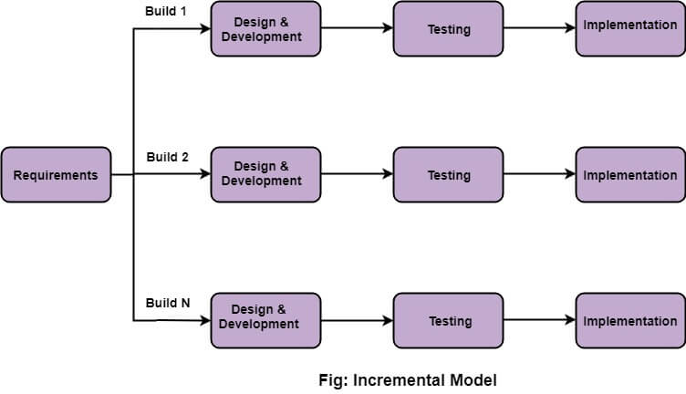

4. DESIGN
4.1 Use case diagram

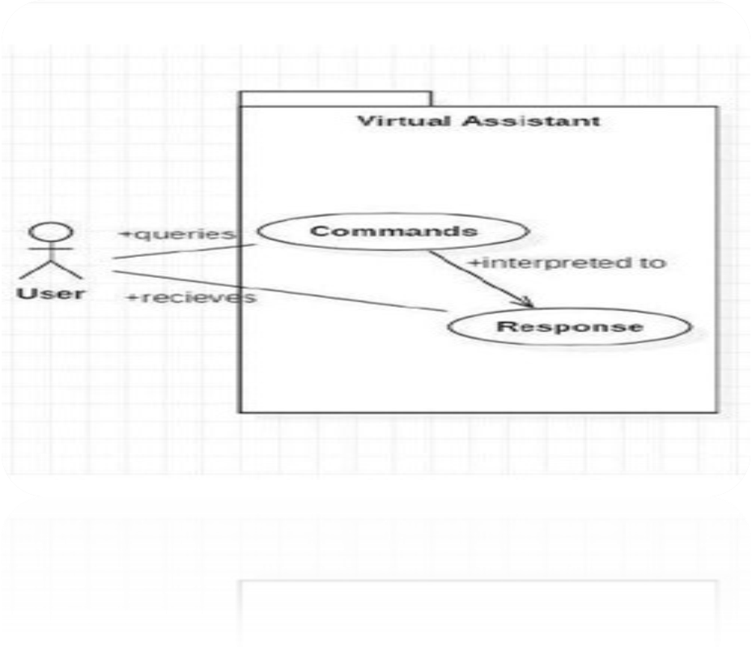

Fig .Use-Case Diagram

4.2 Sequence Diagram

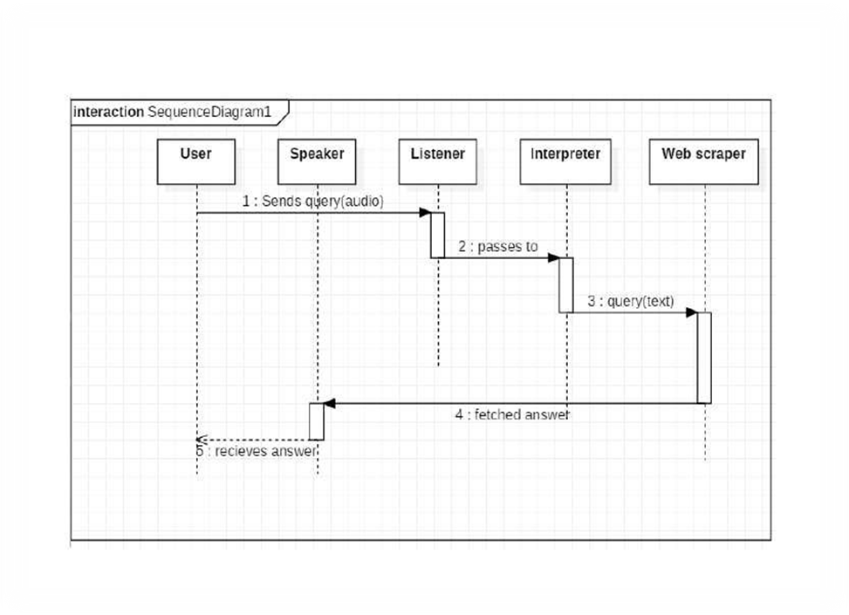

Fig. Sequence Diagram

4.3 Activity Diagram
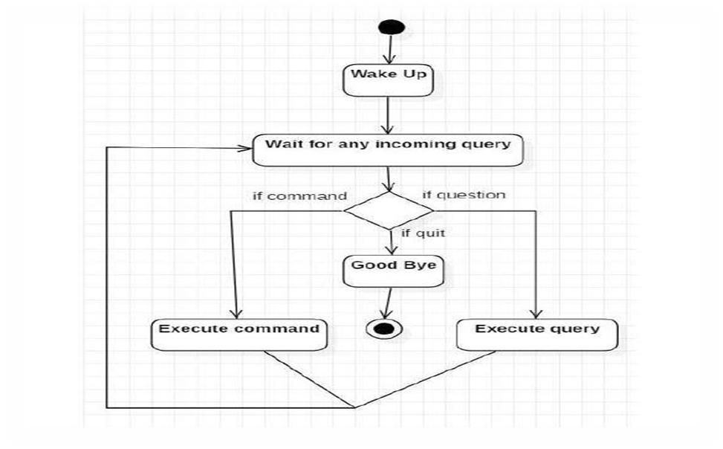

Fig .Activity Diagram

4.4 Class Diagram

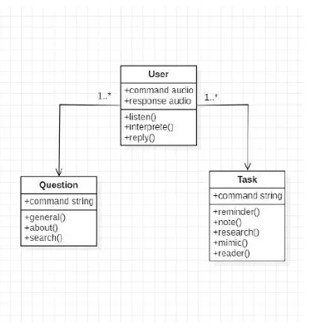
Fig. Class Diagram

4.5 E-R Diagram
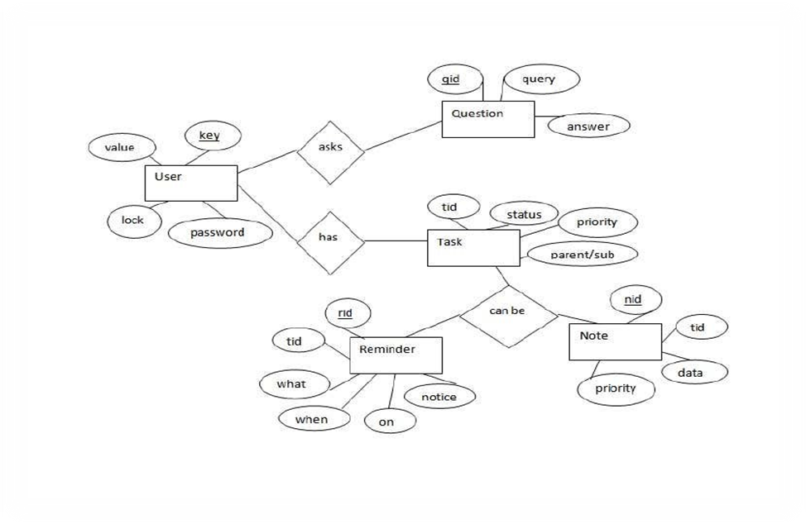

Fig.E-R Diagram

4.6 Data Flow Diagram

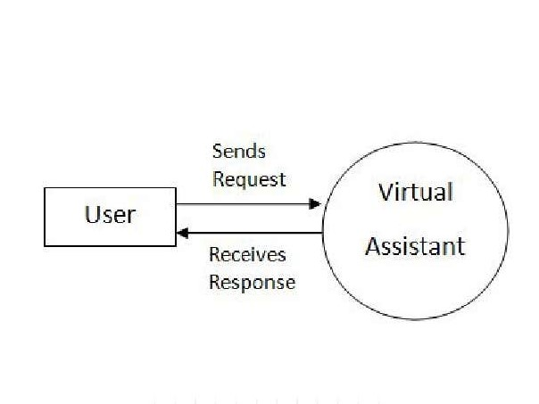
Fig Level 0 DFD

Level 1 dfd

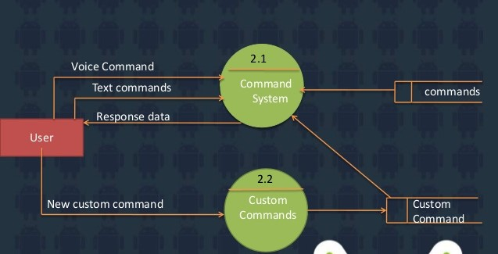

Fig .Level 1 DFD

4.7 Flow Chart
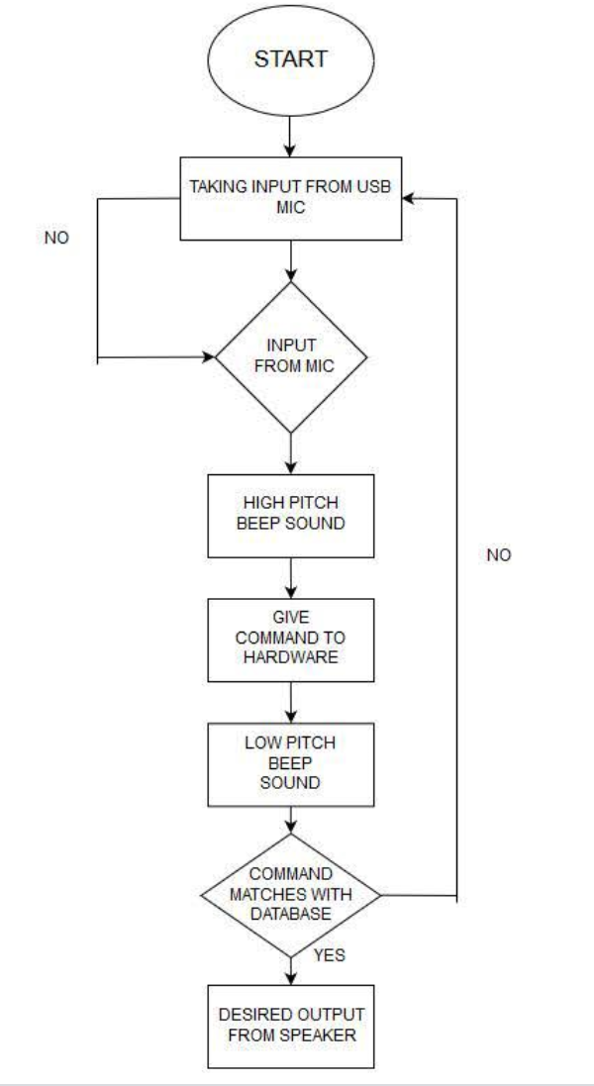

Fig .Flow Chart

5. TECHNICAL DETAILS
5.1 Software Specification
Windows 7(32-bit) or above.
Python 2.7 or later
Chrome Driver
Selenium Web Automation

5.2 Hardware Specification
Minimum processor is required is intel i3.
Minimum RAM is required in this project is 2GB.
Minimum Disk space is available is 20GB

7. TESTING
7.1 Software testing can be stated as the process of
validating and verifying:
  - That all the commands will run correctly;
  - works as expected;
  - can be implemented with the same characteristics.
Black Box Testing:
Testing without knowledge of the internal workings
of theitem being tested. Tests are usually functional.
White Box Testing:
Testing based on an analysis of internal workings
and structure of a piece of software.
sting Used

7.2 Test Case design
Test case 1
Test Title: Response Time
Test ID: T1
Test Priority: High
Test Objective: To make sure that the system respond back time is efficient.
Description:
Time is very critical in a voice based system. As we are not typing inputs, we are speaking them. The system must also reply in a moment. User must get instant response of the query made.
Test Case 2
Test Title: Accuracy
Test ID: T2
Test Priority: High
Test Objective:
To assure that answers retrieved by system are accurate as per gathered data.
Description:
A virtual assistant system is mainly used to get precise answers to any question asked. Getting answer in a moment is of no use if the answer is not correct. Accuracy is of utmost importance in a virtual assistant system.
Test Case 3
Test Title: Approximation
Test ID:t3
Test priority: Moderate
Test Objective: To check approximate answers about calculations.
Description:
There are times when mathematical calculation requires approximate value. For example, if someone asks for value of PI the system must respond with approximate value and not the accurate value. Getting exact value in such cases is undesirable. Note: There might include a few more test cases and these test cases are also subject to change with the final software development.

9. FUTURE ENHANCEMENTS
A recent study shows that a third of the entire population of the US already use virtual assistants in some form (source). Another study made in 2017 showed that 98% believe that they would use voice-controlled assistants 5+ years in the future (source). Naturally, we have become more familiar and comfortable with these voice-controlled services over time. Google, Alexa, Siri, Cortana, Viv, Watson, Bixby, Mycroft. The list is long and still growing.
However, many associate the VA’s with trivial tasks such as setting a timer for the pizza in the oven, playing your favorite music playlist, answering questions you would normally search online, or just simply their inability to understand your question.
Further, the way these applications have been designed makes them a subject for a continuous debate of personal data privacy. Today, VA’s work by recording the user commands, and then sends this voice recording to a cloud processor that identifies the user intention.
The way users express themselves can vary greatly in language, accent, context and tones. Interpreting user intents with such great variations require more computational power than what is typically available in most phones and smart speakers, hence the need for cloud processing.
The voice recordings of the users (I.e. the data) is often by default stored in the vendors own cloud storage, giving them access to huge amounts of personal data that its users might want to keep private. Numerous incidents of privacy breach do not soothe the public opinion on the matter. For instance, there have been reported incidents where VA’s have accidentally recorded private conversations and then, by mistake, forwarded the recording to people in the user’s own contact list (source). Also, user data has been sent to other users (source), or listened to by human employees by the cloud processor (source).

10. CONCLUSION
The world of virtual assistants was born to make life easier for humans. Our tasks can be solved in a matter of seconds just by using our voice.
Virtual Assistants such as Alexa, Cortana, Siri, Google Assistant, will be more and more accurate, which in turn will exponentially increase the number of users who will begin to rely on this technology.
Within the world of marketing, it is a poorly researched strategy, but with great potential we could take advantage of.
With more accurate virtual assistants, we’ll see more Voice Market strategies. Today, we want to launch a challenge: to incorporate these virtual assistants into our email marketing strategy.

REFERENCE AND BIBLIOGRAPHY
Websites referred
www.stackoverflow.com
www.pythonprogramming.net
www.codeacademy.com
www.tutorialspoint.com

Books referred
Python Programming - Kiran Gurbani
Learning Python - Mark Lutz
YouTube Channels referred
CS Dojo
edureka!

APPENDIX
Documents referred
Designing virtual Assistant Software for Task Management using SemanticWeb Technologies and Knowledge Databases- Purushotham Botla
Python code for Artificial Intelligence: Foundations of Computational Agents- David L. Poole and Alan K. Mackworth

Glosssary:

GB -------- GigaByte

Py --------- Python

Modules used in this project:

pyttsx3
speech_recognition
datetime
os
subprocess
tkinter
pytube
cv2
random
requests
wikipedia
requests
webbrowser
pywhatkit
pywhatkit
smtplib
psutil
speedtest
sys
pyjokes
ctypes
wolframalpha

